Lab 4: Data Analysis

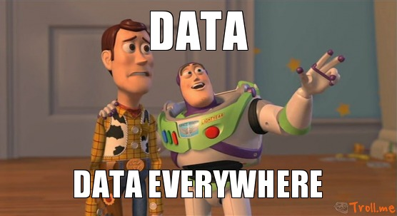
Overview:
As we progress through our lab series, we have highlighted how modeling physics problems can be quite useful; however, we have yet to use python to analyze data. This lab will emphasize data analysis from a previous lab and from data I will supply you. For this lab, you will get much more experience using functions that are already built into the numpy library in addition to being exposed to a new library, matplotlib.

We will be revisiting the fan cart lab to create a “list” of data from your program. This data will consist of velocity changing over time. The end goal will be to calculate the average force experienced by the cart and see if you can match it to your program value.

The last part of the lab will consist of you manipulating a lists of data I have provided you with. Your goal with that data is going to consist of calculating average acceleration, the standard deviation of the velocity, and plotting the velocity over time. To make this task easier, I will provide you with two text documents that will have the time data that pairs up with the velocity data.

Similarly to lab 3, I am going to provide a small amount of code for you to work with. The only code I am going to provide are libraries and a working copy of the lab 2 simulation. It will be up to you to figure out the rest. I will provide some supplemental resources to help review our in-class programming demo.

Part 1: Tutorial
I have included two resources for you to look at. The first resource is a video that will review how to read files into your program. This will allow you to obtain data from files such as text documents. The second video will review what an array is and how we can use them for our data in these two programs. Below are the video links and descriptions on how to find the videos. Just as we have done in previous lab assignments, you will write summaries for each video, one paragraph in length, and write any notes down that you feel are important.

Reading Files: https://www.youtube.com/watch?v=4qWvOLl5dZU
You can find the python 101 reading files video under the YouTube user “howcode”

Arrays and Lists: https://www.youtube.com/watch?v=URgQGuKwZQQ
You can find “Python: arrays, lists, and list builders” under the YouTube user “Barry Brown”

Part 2: Revisiting the Fan Cart Simulation
For this part of the lab, I want you to copy and paste the code I have given you below. This code will serve as your foundation for the code. Remove any part of the code that runs the visualization component. You will then modify the program to create a list of velocities.

Once you have your list of velocities, you will use the built in numpy functions to calculate the average acceleration. Once you have average acceleration, you will use newton's second law:

to calculate the average force. You will then print your answer to the screen and see if it matches that force vector you used in your program. I will provide some of the code to make the graphs, but it will be up to you to complete the code.

Hint: You will want to recall that momentum, p, is equal to mass times velocity. Also, the change in momentum, impulse, is equal to an external force applied over time. If you divide both of those statements by mass, you get velocity and the change in velocity.

After your program runs and works successfully, save your work as Lab4Part2 and I will collect it during our in-class lab period.

from __future__ import division
from visual import*
import numpy as np
import matplotlib.pyplot as plt

mcart = 0.80 #mass in kilograms
pcart = mcart*vector(0.5,0,0.15) #momentum of cart
t = 0 #initial time
deltat = 0.01 #change in time in seconds
fEx = vector(0.0526,0,0.016)#External force acting upon the cart
print "cart momentum = ", pcart
track = (box(pos = vector(0, -0.025, 0),
size = (2.0, 0.05, 1.75), color = color.white))
cart = (box(pos = vector(0.95, 0.027, 0),
size = (0.1, 0.04, 0.06), color = color.green))

while t <= 15.2:
rate(100)
pcart = pcart - fEx*deltat #Change in momentum
cart.pos = cart.pos - (pcart/mcart)*deltat #Change in cart position.
t = t + deltat
print('end of program')

Part 3: Reading Files for Data Analysis
For this part of the lab, you will be given a table of data that you must analyze. The data I will be giving you will be two columns of numbers, time and velocity, that you will have to analyze and graph. The goal of this part of the lab is for you to do most of the programming on your own. I will include comments, libraries, and incomplete graphing code to assist you, but this time I will leave out most of the variables. You have to create your own variables and make sure they work within the context of the program. Below, I have provided you with an outline of goals along with libraries and comments for your code. Once your program runs, save it as Lab4Part3. I will review it with you during lab in-class and approve it for submission

- Calculate average acceleration
- Calculate standard deviation of the velocity data
- Graph velocity vs. time

import numpy as np
import matplotlib.pyplot as plt
#Above are the libraries you will need to import for this program.
#An array for time, use map(float, array) to convert you list
#An array for velocity, use map(float, array) to convert you list
#Assign variables the size of each list to help you in your calculations
#Write your code here to calculate acceleration and the standard deviation.
#Write your print statments here that output average acceleration and std.
#This is the code for showing your plot, do not modify anything else other than
#locations where you see XXXXXX, replace XXXXXX with your time and velocity
#list
plt.scatter(XXXXX, XXXXX)
plt.title("Intial velocity Vs Time")
plt.xlabel("Intial Velocity (m/s)")
plt.ylabel("Travel time (s)")
plt.show()

